## EXPERIMENT #1

**AIM:**

Design the following static webpages required for an online book store website. HOMEPAGE:  
The static home page must contain three frames.  
Top frame: Logo and the college name and links to Homepage, Login  
page, Registration page, Catalogue page and Cart page (the description  
of these pages will be given below).   
For example: When you click the link “CSE” the catalogue for CSE Books should be  
displayed in the Right frame. Right frame: The pages to the links in the left frame must be  
loaded here. Initially this page contains description of the web site.

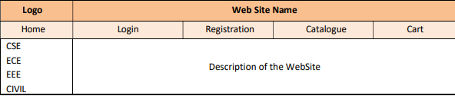

**CODE**

**Left frame**

**<!DOCTYPE html>**

**<html lang="en">**

**<head>**

**<meta charset="UTF-8">**

**<meta name="viewport" content="width=device-width, initial-scale=1.0">**

**<title>Document</title>**

**</head>**

**<body>**

**<ol type="a" start="100">**

**<!-- a for abc .... A for ABC ... i for i,ii,iii -->**

**<li> <a href="https://abes.ac.in/computer-science-engineering.php" target="cols2"> CSE </a></li> <br>**

**<li> <a href="https://abes.ac.in/electrical-and-computer-engineering.php" target="cols2"> ECE</a></li> <br>**

**<li> <a href="https://abes.ac.in/IT-department.php" target="cols2"> IT</a></li> <br>**

**<li> <a href="https://abes.ac.in/mechanical-engineering.php" target="cols2"> MECHANICAL</a></li> <br>**

**</ol>**

